**ECE -511 Project Report**

**Elderly Asset Distress Alarm System (EADAS)**

Submitted by

Sammy Lin(G# )

Nisarg Patel(G# )

Abhimanyu Chopra(G# )

Lalitha Bhaskaruni(G# )

**Abstract:**

Elderly Asset Distress Alarm System (EADAS) is an alarm system that notifies the distresses in elderly, like Spike in heart rate or change in orientation through a SMS to the configured party and a continuous beep sound. The motivation for this project came from the idea to develop an embedded system that can be useful in real environment. The EADAS is built around the 16 bit microcontroller MSP-430, by utilizing many exciting features of it. The aim of the project was to build the alarm system that can detect a distress in the person and send out notifications. Heart rate sensor is used for continuous monitoring of the heart rate, Accelerometer + Gyroscope is used to monitor the orientation of the person. The LCD is used to display the heart rate and orientation of the person. The GSM + GPS module is used to send out a message when distress has occurred.

**Introduction:**

**Motivation:**

Necessity is the mother of creation. In today’s busy world it is not always possible to constantly monitor elderly people in person. This problem coupled with our interest to build a system useful for real time environment has strongly inspired us to build EADAS. The optimal usage of science and technology has made a man’s life easier, safer and comfortable. We were motivated to build an alarm system that optimized the use of MSP-430 and also that could fulfill the requirements of ECE-511 project.

**System functionality:**

The multiple operations of EADAS have been broke down in to different blocks which are then interfaced and incorporated to MSP-430 based upon their functionalities. The heart rate is monitored using a heart rate sensor. The change in orientation is monitored by the Accelerometer + Gyroscope. The LCD is used to display the heart rate and orientation of a person. The function of the GSM + GPS device is to send out alert messages when there is sudden change in heart rate or position of the person. Though the system functionality looks simple it was difficult to interface and integrate all devices.

Heart rate sensor

Analog

**MSP-430**

**KEYPAD**

LCD

Battery

FONA GSM+GPS

LSM9DS0

(Accelerometer + Gyroscope)

GPIO

SPI

UART

**Fig: Block Diagram of EADAS**

**Hardware Components:**

**MSP-430FR6989:**

The TI MSP-430FR6989 is an ultra low power microcontroller that accommodates features like 16 bit RISC CPU with 128KB of programmable memory. The MSP430FR6989 has 83 general purpose input output pins, 5 16-bit timers, an inbuilt LCD, real time clock and 12 bit ADC. It operates under a voltage range of 1.8 V to 3.6 V. It has seven Low power modes which is useful in extending battery life in energy challenged applications.

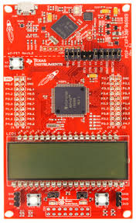

Fig 2: MSP430FR6989

**LSM9DS0:**

The LSM9DS0 versatile motion sensing on chip that contains 3 acceleration channels, 3 angular rate channels, 3 magnetic field channels which provides a 16 bit data output. It includes I2C serial bus interface and SPI serial standard interface. We communicate with MSP430 using SPI serial standard interface in this project.

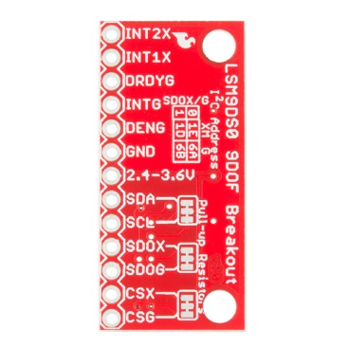

**Heart Rate Sensor:**

Pulse sensor amped from Sparkfun is a plug and play heart rate sensor. This is basically a combination of optical pulse sensor and a circuit for amplification and noise cancellation. It operates at a 3V to 5V voltage range. Here the pulse sensor is connected to pin 8.4 of MSP430.

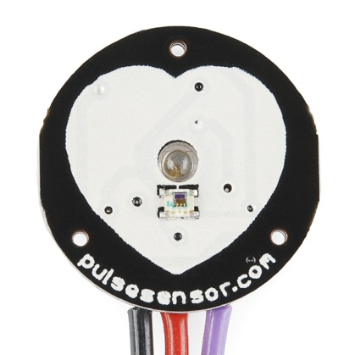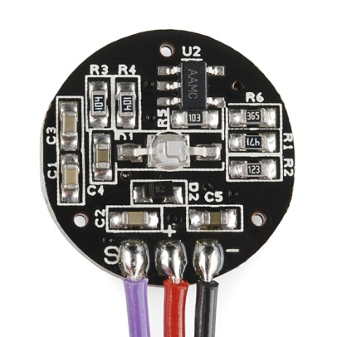

Fig 4: Pulse sensor from spark fun

**LCD:**

The incorporated Liquid Crystal Display (LCD) in the MSP430FR6989 is controlled by a LCD_C controller. It is used in interfacing of a program with LCD in a simplistic manner. The LCD-C controller controls the LCD segment. It supports static, 2-MUX, 3-MUX and 4-MUX LCD types. The LCD_C controller supports features like blinking, display memory, automatic signal generation. The contrast of the LCD can be configured using software.

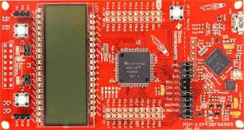

Fig 6: MSP430FR6989 on board LCD

**FONA GSM+GPS:**

The Adafruit FONA device provides all in one cellular system which provides us with a feasibility to track location Send a SMS or make a voice call. It has a SIM slot which supports a 2G SIM. The RX and TX pins are used for communication with the MSP430 over UART channel. A rechargeable Lipoly battery is used for power supply making it a on the go device. The Lipoly battery can be charged using the USB port provided on board.

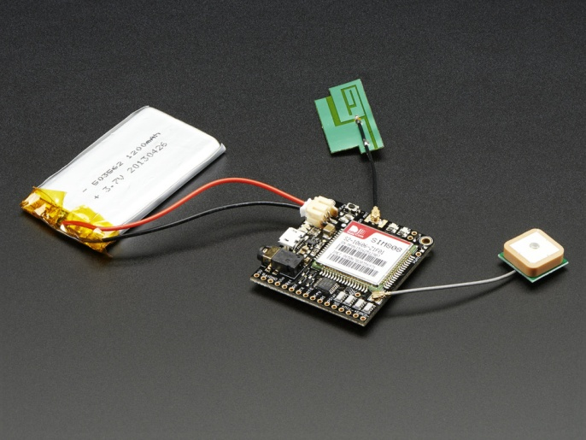 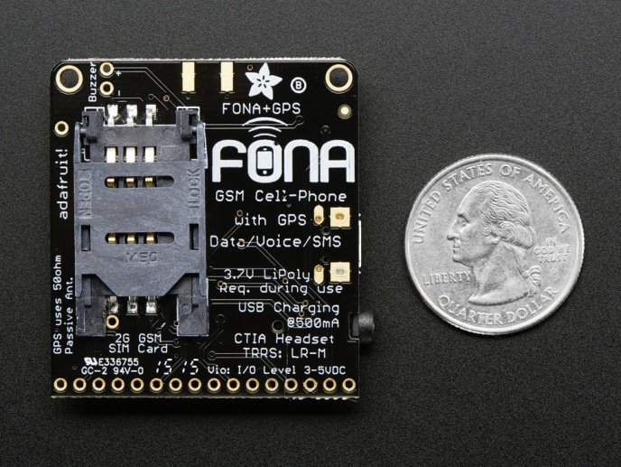

Fig 7 : FONA module with a battery supply Fig 8: SIM slot of the FONA module